Nathan Doan

Professor Kemper

PHYS 121L Sec. 4

1 March 2024

**Sample Calculations**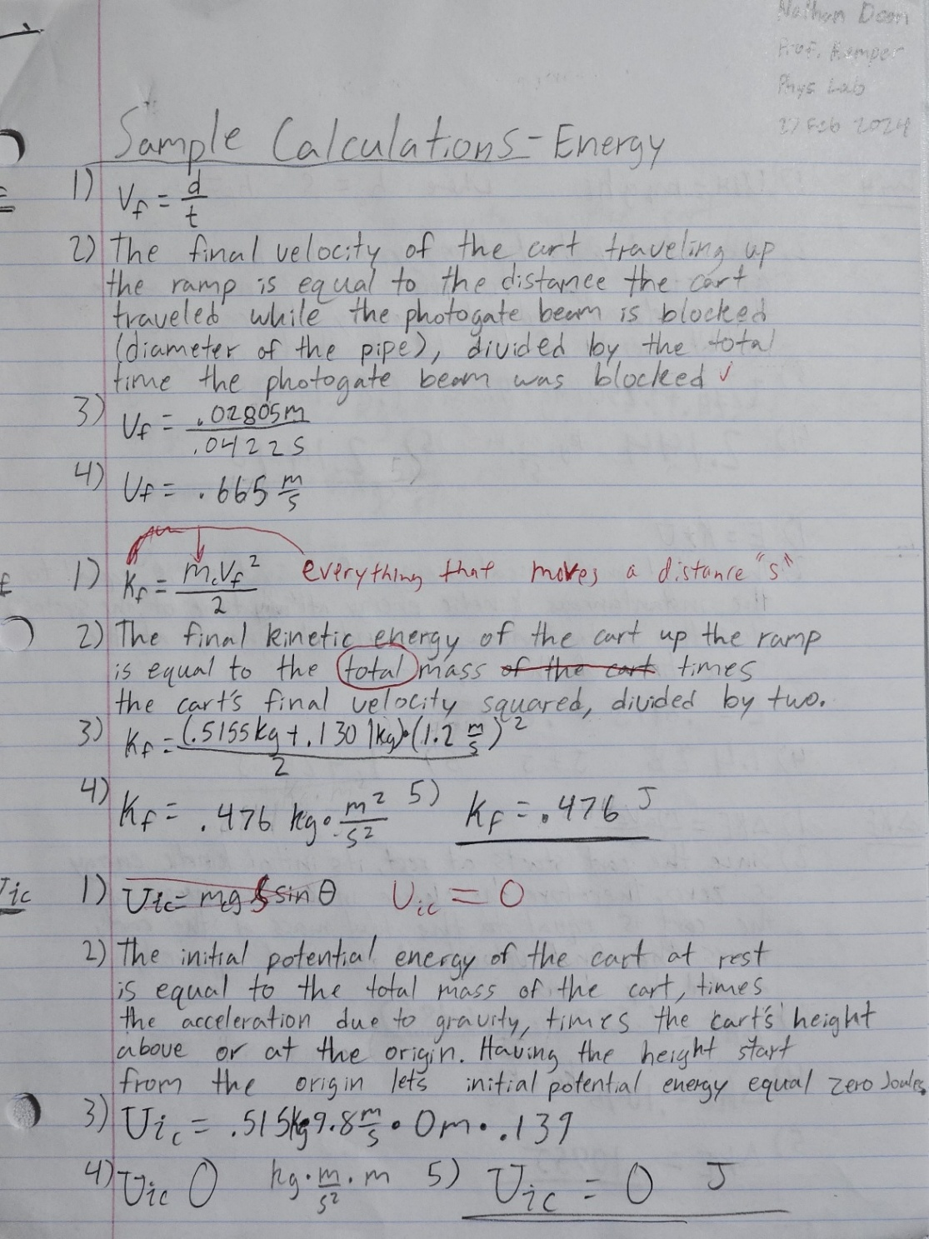

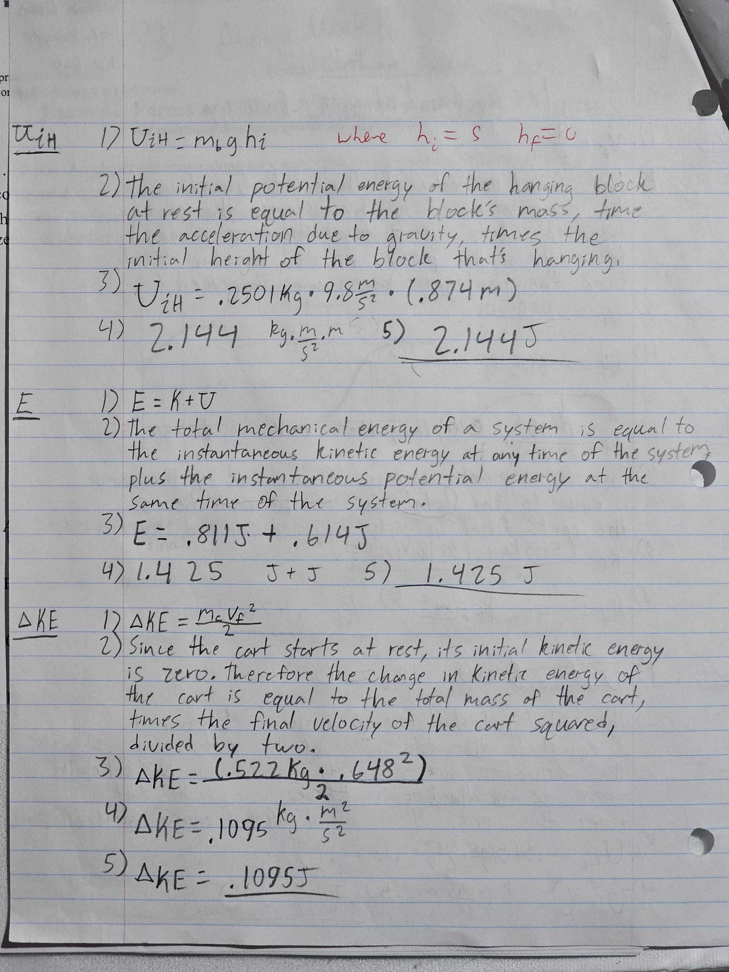

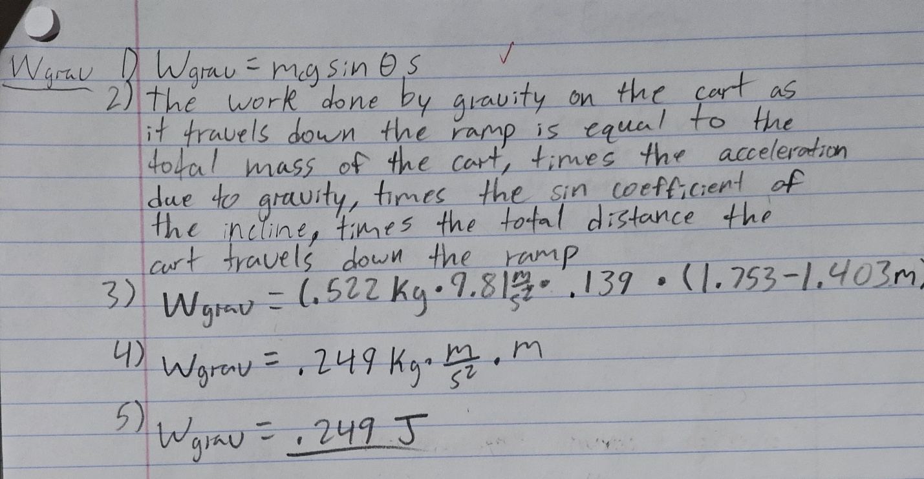

**Challenge**

To find the time it takes for a cart to travel 40cm down a hill inclined at 8 degrees with an opposing force of a pulley, we looked at the conservation of energy equation. Since there is no work done by non-conservative forces the initial mechanical energy must equal the final mechanical energy. We know that the initial potential energy of the hanger is 0 because it starts at the bottom, likewise the final potential energy of the cart is also 0. Setting this equation equal to the final kinetic energy of the cart is equal to the initial potential energy of the cart plus the final potential energy of the hanger, subtracted by our y-intercept. We can then calculate the initial potential energy of the cart using the potential energy formula, mass times gravity times distance time the sin angle. We can also calculate the final potential energy of the hanger using the same equation without the sin angle. Solving for the final kinetic energy of the cart yields 0.109 J. We now need to solve for the velocity of the final kinetic energy of the cart to find the time taken to travel 40cm. Using the kinetic energy equation, we solve for the final velocity of the cart. Finally, we then use the distance and velocity equation to solve for time, yielding 0.0441 seconds.

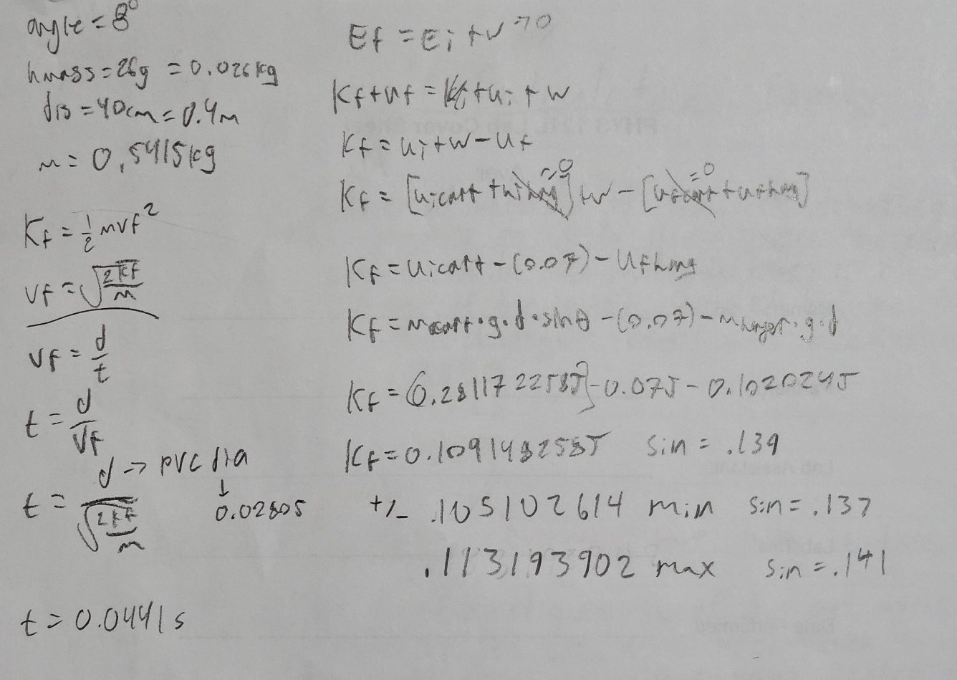

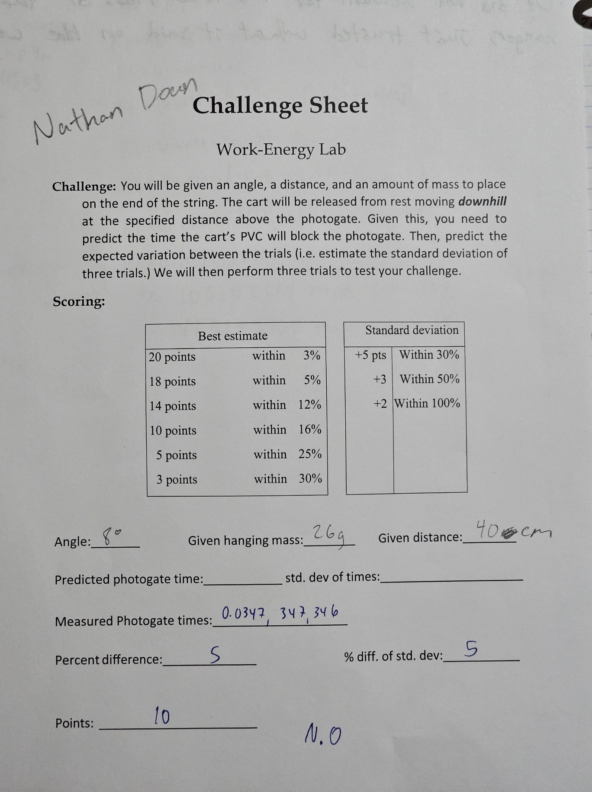

**Discussion Q’s**

1. (16 pts) Let us explore whether or not mechanical energy is conserved in part 1. To do this we will ask if there was significant non-conservative work done on the system. Look at page 2 of this handout to get started. Then:

a. Look at your Results for the graph in part 1. Do they support the hypothesis that mechanical energy was conserved?

* Looking at our results from part 1 of the lab, mechanical energy was not conserved in the system.

b. Now look at your calculations from the last step in part 1 (step 8). Which Result in part 1 does friction affect? Is friction significant, and if so, what type(s) of error does it cause? Is friction a plausible cause of disagreement between Results and the Expected values in this lab?

* In part 1 of the lab, friction affects the torque of the pulley between the hanging mass and the cart. This friction is not significant. Rather, the plausible cause of disagreement between expected values and result is due to the mismeasurement of mass. When we measured the mass of the pulley, we only measured the hanger on the balance beam. Therefore, the masses we added to the hanger could have different masses than what it states on the weight.

2. Check to see if the reading error of the hanging masses is significant: In Excel, change one or more of your hanging mass values by the reading error of your mass measurements. (Adding up the slotted mass values is a mass measurement.) If your Result’s best estimate changes by more than the uncertainty, the reading error is significant. Is this reading error significant? Is it possible to improve the precision of this lab with this information? (9 pts)

* The reading error of the hanging masses is not significant. However, the reading error is the weights are unknown, therefore, to improve the precision of this lab, we should have measured the mass of the hanger plus the mass of the weights on the balance beam to obtain an increasingly accurate measurement of mass.